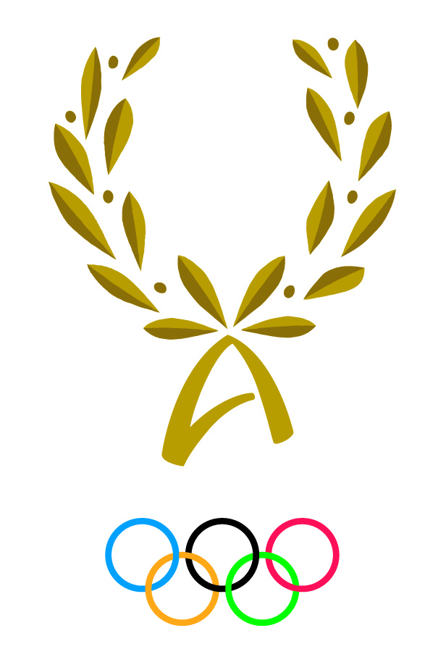
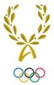
INTERNATIONAL OLYMPIC ACADEMY
52, Dimitrios Vikelas Avenue, 152 33 Halandri – Athens, Greece

4th International Session for Olympic Medallists or Olympians
Monday, 2/7/2018 – Monday, 9/7/2018

PARTICIPANT’S PERSONAL HISTORY FORM

National Olympic Committee/Academy/IF/IOC Athletes’ Commission:

Surname: Date of Birth:
First name: Gender:
Nationality: Tel:
Address: E-mail:

Knowledge of languages
What is your mother tongue?
KNOWLEDGE OF IOA OFFICIAL LANGUAGES | READ |  | WRITE |  | SPEAK |  | UNDERSTAND
 | Easily | Not easily | Easily | Not easily | Easily | Not easily | Easily | Not easily
ENGLISH
FRENCH
GREEK

Which Discussion Group would you like to participate in? English-speaking French-speaking
In which Olympic Games did you participate?
Sport(s):
Medal(s) or places won in Olympic Games:

Medals awarded in world championships:

Education Give full details:
A. Secondary school, technical school or apprenticeship
Name of institution, place and country | Type | Years attended |  | Main course of studies / Certificates or diplomas obtained
 |  | from | to

B. Bachelor Studies
Name of institution, place and country | Type | Years attended |  | Certificates or diplomas obtained
 |  | from | to
C. Postgraduate studies
Name of institution, place and country | Type | Years attended |  | Certificates or diplomas obtained
 |  | from | to
D. PhD studies
Name of institution, place and country | Type | Years attended |  | Certificates or diplomas obtained
 |  | from | to

Current profession:

Have you been involved with any educational program implemented by your country’s NOC or NOA?

Career as a sports official: (Please list duties assumed within a club or at a regional, national or int’l level)

State in 5 lines why you wish to participate in the IOA Session:

Remarks:

DATE: SIGNATURE (Participant):

Confirmed by the NOC/NOA/IF of SIGNATURE & OFFICIAL SEAL:
/Athletes’ Commission
--------------------------
Note: Please return this questionnaire, fully completed and officially signed and sealed,
to the International Olympic Academy by Friday 30 March 2018.
Preferably by e-mail: m.katsadoraki@ioa.org.gr OR by post: 52, Dimitrios Vikelas Avenue,
152 33 Halandri – Athens, Greece.
Please include two recent passport-size photos (electronic or hard copies).

