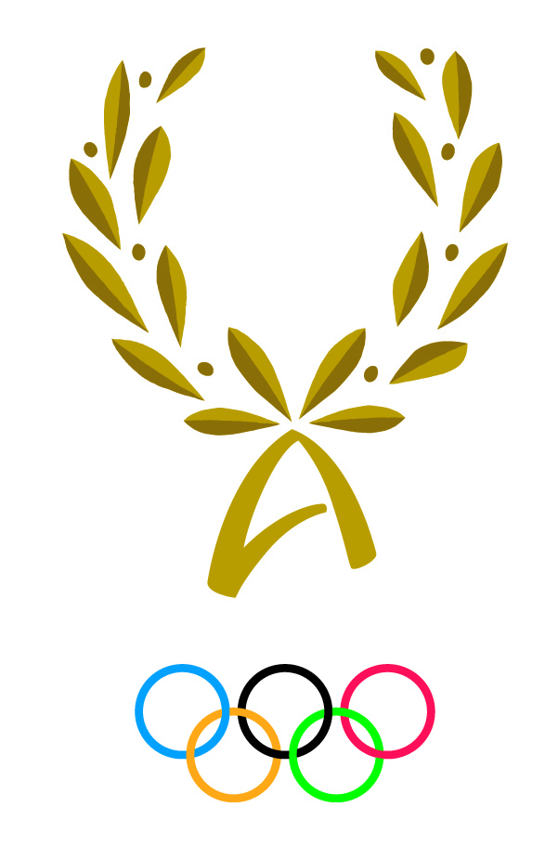
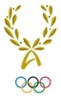
INTERNATIONAL OLYMPIC ACADEMY

52, Dimitrios Vikelas Avenue, 152 33 Halandri – Athens, Greece
14th Joint International Session for Presidents or Directors of National Olympic Academies & Officials of National Olympic Committees
Sunday, 6/5/2018 – Sunday, 13/5/2018

PARTICIPANT’S PERSONAL HISTORY FORM

National Olympic Academy / Committee:
Surname:
First name: Date of birth:
Nationality: Gender: Tel:
Address: E-mail:
Current position at the NOA/NOC:
Knowledge of languages
What is your mother tongue?
KNOWLEDGE OF IOA OFFICIALS LANGUAGES | READ |  | WRITE |  | SPEAK |  | UNDERSTAND
 | Easily | Not easily | Easily | Not easily | Easily | Not easily | Easily | Not easily
ENGLISH
FRENCH
GREEK

Which discussion group you would like to participate in: English-speaking group French-speaking group

Education (Give full details)
A. Secondary school, technical school or apprenticeship
Name of institution, place and country | Type | Years attended |  | Certificates or diplomas obtained
 |  | from | to
B. Bachelor studies
Name of institution, place and country | Type | Years attended |  | Certificates or diplomas obtained
 |  | from | to
C. Postgraduate studies
Name of institution, place and country | Type | Years attended |  | Certificates or diplomas obtained
 |  | from | to
D. PhD studies
Name of institution, place and country | Type | Years attended |  | Certificates or diplomas obtained
 |  | from | to

Profession:

Sports career as an athlete:

Sports practiced in the past:

Sports currently practiced:

Awards:

Please indicate the associations or clubs of which you are a member:

Career as a sports official: (Please list duties assumed within a club or at regional, national or international level)

What is your particular interest in the field of sports:

State in 5 lines why you wished to participate in the I.O.A. Session:

Write down any publications you have issued:

REMARKS:

DATE: SIGNATURE (Participant):

Confirmed by the NOC / NOA of SIGNATURE & OFFICIAL SEAL
OF NOC / NOA:

Note: Please return this questionnaire, fully completed, by 2 February 2018 to the International Olympic Academy.
Preferably by e-mail at: a.karaiskou@ioa.org.gr or ioa@ioa.org.gr OR
by Post at: 52, Dimitrios Vikelas Avenue, 152 33 Halandri – Athens, Greece
Please include two recent passport-size photos (electronically or hard copies)

